**DevOps With AWS**

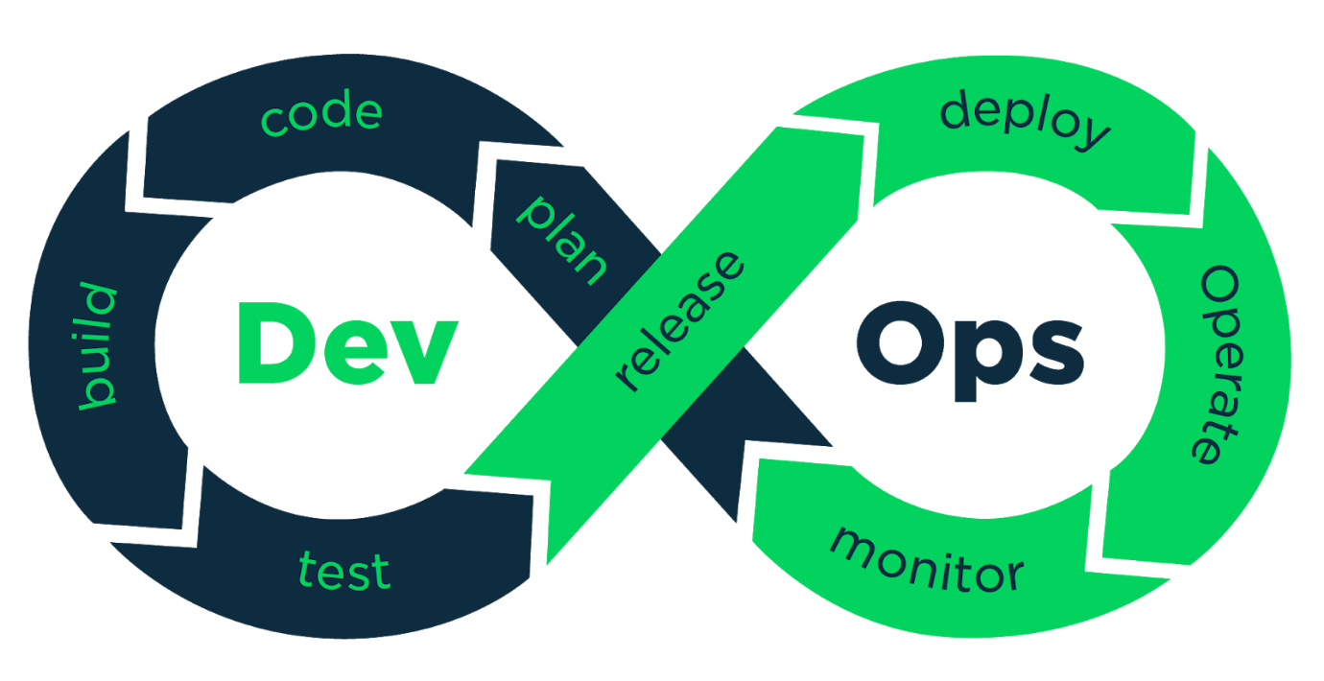

**DEVOPS WITH AWS COURSE CONTENT**

Date: …………...… Timings: …………

Duration: …………. Fee: ………………

Faculty: ……………………

Module-1: DevOps Introduction

* What Is SDLC
* Waterfall Model
* Advantages & Disadvantages
* Agile Methodology
* Advantages & Disadvantages
* Scrum
* DevOps History
* DevOps Lifecycle
* Need Of DevOps
* Roles & Responsibilities
* Before And After DevOps
* DevOps Goals
* DevOps Tools
* Advantages
* Roadmap

Module-2: Basic Terminology

* Client-Server Architecture
* Network Basic Concepts
* Virtualization Overview
* Cloud Computing

Module-3: AWS Services Overview

AWS Introduction

AWS Account Creation

Security (IAM)

Compute (EC2)

Network (VPC)

Module-4: Linux

* Linux Introduction
* Flavors On Linux
* Linux History
* Linux Advantages
* System Information
* Hardware Information
* File Commands
* Vim Editor
* Users & Groups
* File Permissions
* Networking
* Compression/Archive
* Disk Usage
* Package Installation
* Fhs/Directory System
* Sed Filters
* Grep Filters
* Some Additional Commands
* Assignment

Module-5: Shell Scripting

* What Is Bash
* Bash Script
* User Input
* Variables
* Date Formatting
* If Statement
* Else If Statement
* Case
* For Loop
* While Loop
* Until
* Bash String
* String Length
* Concatenation String
* Read File
* Write File
* Bash Comments
* Bash Quotes

Module-6: Version Control System (GIT)

* What Is VCS
* VCS History
* SCCM
* Revision Control System
* Subversion
* Concurrent Versions System
* Why Git
* Git Stages
* Working Directory
* Staging Area
* Repository (Local, Central, Remote)
* Git Installation
* Git Lifecycle
* Git Logs
* Git Push
* Git Pull
* Git Cloning
* Git Branch
* Git Merge
* Git Stash
* Git Cherry Pick
* Git Revert
* Git Merge
* Merge Conflicts
* Commit A File Using Git
* Configuration Of User
* Ignoring Content
* Branching Strategies
* Git Branch (Create, Delete, Rename, Switch)

Module-7: Build Tool (Maven)

* Introduction
* Maven Objectives
* Project Information
* Features
* Download Requirements
* Plugins
* Maven Goals
* What Maven Does
* What Is Build Tool?
* Pom.Xml
* Requirements For Build
* Maven Architecture
* Maven Build Life Cycle
* Maven Directory Structure
* Generating Jar File
* Java Project Structure
* Problems Without Maven
* Maven Vs Ant
* Interview Questions

Module-8: Jenkins

* Introduction
* Workflow
* Continuous Integration
* Continuous Delivery
* Continuous Deployment
* Jenkins Setup
* Jenkins Setup Requirements
* Java Installation
* Git Integration
* Maven Integration
* Jobs Types In Jenkins
* Free Style Job
* Pipeline
* Multibranch
* Maven Job, Task
* Parameter Building
* Choice Parameter
* File Parameter
* String Parameter
* Multi-String Parameter
* Credentials Parameter
* Branch Building
* Schedule Project
* Cron Jobs
* Poll Scm
* Webhooks
* Linked Projects
* Up Stream
* Down Stream
* Build Pipeline View
* Master – Slave Architecture
* Master – Slave Setup
* Distributing Builds
* Configuration Changes
* Environment Variables
* Local Variable
* Global Variable
* Timeout
* Time Stamps
* Custom Workspace
* Workspace Access
* Disabling Jobs
* Renaming Jobs
* Build Pipeline View
* Shell Execute
* Build Triggers
* Authentication For Build Trigger
* Build Through Terminal
* Throttle Build
* Pipelines
* Scripted Pipelines
* Declarative Pipelines
* Pipeline Stages
* Pipeline Syntax
* Hello World Pipeline
* Staged Pipeline
* Multi-Staged Pipeline
* Pipeline As a Code
* Multiple Commands on Pipeline
* Paac Variables
* Paac Parameters
* Paac Input Parameter
* Paac Postbuild
* Paac Input
* Pipeline Logs
* Pipeline Through Build Pipeline
* Pipeline Post-Build
* Plugin Management
* Console Output
* Permalinks
* List View
* Custom View
* Build History
* Cron Syntax Generator
* Editing Build Info
* Agent Setup
* User Management
* Adding Users
* Assigning Roles
* Managing Roles
* Blue Ocean Introduction
* Admin Activities
* Port Changes
* Java Issues
* Server Level Issues
* Console Level Issues
* Code Level Issues
* Advantages
* Jenkins Alternatives
* Jenkins Metrics & Trends
* Jenkins Vs Bamboo
* Interview Question

Module-9: Ansible

* Ansible Introduction
* Ansible Use cases
* Ansible History
* Ansible Architecture
* Ansible Inventory Host Pattern
* Ansible Execution Types
* Ad-Hoc Commands
* Working With Adhoc
* Ansible Modules Introduction
* Working With Ansible Modules
* Ansible Playbooks
* Yaml Introduction
* Yaml Indentation & Separation
* Commenting Sections
* Ansible Variables
* Ansible Handlers
* Ansible Loops
* Ansible Conditions
* Ansible Vault
* Ansible Roles
* Ansible Tags
* Ansible Dry Run
* Ansible Pip
* Ansible Galaxy
* Ansible Userinfo
* Ansible Setup Modules
* Ansible Debug Module
* Ansible Raw Module
* Ansible Command Module
* Ansible Copy Module
* Ansible Shell
* Ansible Strategies
* Ansible Jinja2
* Creating Local Resources
* Ansible Git Integration
* Deploying Ec2 Instance
* Deploying Tomcat Webapp Server
* Admin Activities
* Server Metrics Collections
* Docker With Ansible
* Jenkins With Ansible
* Static Website Using Playbook
* Advantages & Disadvantages
* Creating Resources Using Ansible
* Asynchronous Actions & Polling
* Ansible Vs Chef Vs Puppet Vs Salt Stack
* Interview Questions

Module-10: Docker

* Microservices Introduction
* Difference Between Monolithic & Microservices
* Micro Services Advantages
* Micro Services Limitations
* Virtualization Intro
* Docker Vs VMs Vs Servers
* Before Docker Vs After Docker
* Docker Introduction
* Understanding Docker
* Docker Architecture
* Docker Client
* Docker Server
* Docker Daemon
* Docker Objects
* Docker Basic Commands
* Stop Vs Kill
* Run Vs Cmd Vs Entrypoint
* Add Vs Copy
* Run Vs Pull
* Docker Images
* Docker Containers
* Docker Volumes
* Working With Containers
* Build Image from Container
* Creating Custom Images
* Ways Of Container Creation
* Docker File
  + Docker File Components
  + Docker File Creation
* Docker Volumes
  + Uses Of Volumes
  + Creating Volumes
  + Creating Volumes by Using Commands
  + Volumes (Container - Container)
  + Volumes (Host - Container)
  + Creating Volume from File
  + Creating Volume Form Commands
  + Volume Mounting
  + Volume Modifying
* Docker Port Mapping
* Docker Multistage Build
* Creating Jenkins by Docker
* Docker Registry Types
  + Cloud Based Registry Vs Local Registry
  + Docker Login
  + Docker Hub Account Creation
  + Image Pushing to Registry
* Docker Networking
* Docker Swarm
  + Docker Swarm Architecture
  + Docker Swarm Components
  + Docker Swarm Manager
  + Docker Swarm Worker
  + Docker Swarm Service
* Docker Portainer
* Docker Compose
  + Docker Compose Advantages
  + Docker Compose Installation
  + Docker Compose File
  + Docker Compose File in Json
  + Docker Compose File in Yaml
  + Docker Compose Single Service
  + Docker Compose Multi Services
  + Docker Compose File Commands
  + Docker Compose Scale
* Docker Stack
* Portainer Introduction
* Portainer Use Cases
* Portainer Setup
* Working With Portainer
* Memory Management
* Memory Sharing
* Allocating CPU
* Limiting The Hardware B/W Containers
* Docker Networking
* Bridge Network
* Portainer
* Installing Gui
* Working With Portainer Gui
* Metrics Collections Using Gui
* Some Advance Commands
* Interview Questions

Module-11: Kubernetes

* Container Orchestration
* Kubernetes Introduction
* Architecture
* Master Components
* Node Components
* Working With K8s
* Role Of Master
* Components Of Control Plane
  + Kube-Api Server
  + Etcd
  + Features
  + Kube-Scheduler
  + Control Manager
  + Node Components
  + Kubelet
  + Container Engine
  + Kube-Proxy
* Pod
* Pod Limitations
* Pod Multi Container Pod
* Minikube Intro
* Single Node Cluster
* Replicaset
* Replica Controller
* Drawback Of Daemon set
* Deployments
* Rolling Updates
* Scaling Pods
* Kops
  + Kops Advantages
  + Kops Installation
* Kubectl Installation
* Scaling Cluster
* Cluster Management
* Cluster Creation Using Kops
* Deploying A Pod
* Manifest Files
* Name Spaces
* Implementing Namespaces
* Kubecolor
* Pod Deployment by Manifest
* Limitations
* Service In Kubernetes
* Types Of Services
  + Cluster Ip
  + Node Port
  + Load Balancer
* Use Cases of Config Maps
* Implementing Config Maps
* Data Vs Binary Data
* Immutable Configmaps
* Container Variables
* Passing Variables from Cli
* Env Variables
* Secrets
* Immutable Secrets
* Configmaps Vs Secrets
* Nodeport Vs Clusterip Vs Lb
* Higher Level K8s Objects
* Important Notations
* Scaleup Problems
* Features
* Troubelshooting Issues
* Docker Swarm Vs K8s
* Kubeadm Introduction
* Kubespray Introduction
* Kops Vs Kubeadm Vs Kubespray
* Interview Questions

Module-12: Code & Artifact Storage

NEXUS:

* Intro
* Use Cases
* Setup
* Creating Repo
* Creating Users

SONARQUBE:

* Intro
* Advatnages
* Setup
* Connecting